|  |  |
| --- | --- |
| UMass-Lowell-logo.png (295×358) | **Preliminary Report** |
|  |  | |
| Mason Moser | | |
| Giovan Panzanella  Ryan Sanchez Garcia  Sajid Hossain  Jay Weitzen  Thomas Brady | | |
| EECE.3991.201 | | |
| Due date: 10/25/2024 | |
|  | |  |

I. INTRODUCTION

The Charles Stark Draper Laboratory is a renowned not-for-profit research and development company in Cambridge, Massachusetts. Draper Labs is at the forefront of tackling significant challenges across various industries including national security, space exploration, health care, and energy. One of the critical issues it aims to address is the substantial financial loss faced by the biopharmaceutical industry. This causes industry to lose around $35 billion annually due to product failures during transit. Environmental factors such as humidity, temperature fluctuations, and light exposure severely impact the effectiveness of these pharmaceuticals which lead to waste. This report discusses the Smart Pharmaceutical Asset Tracker (SPAT) project, which is designed to mitigate these losses by offering a solution to monitor environmental conditions during pharmaceutical transportation.

The project’s target customer is the biopharmaceutical industry. The project aims to give a solution to companies who want to protect temperature-sensitive products during transportation. SPAT will deliver a small, portable electronics module capable of monitoring and broadcasting crucial environmental data including temperature, humidity, and other relevant metrics to end-users. This document will explore different technical aspects of the project including the project's background, the current challenges in pharmaceutical transportation, the goals of the tracker, and the future development of the project. Additionally, the report will provide insight into the proposed solution including the integration of GPS, sensors, and power electronics.

II. COMPANY INFORMATION

The company sponsoring this project is Draper Laboratory. Draper is a current space and defense contractor stationed in the United States. Within the company they have categorized their work into four different sections biotechnology systems, electronic systems, strategic systems, and space systems. Within biotechnology systems Draper focuses on biodefense and biomedical. In biodefense Draper looks to develop solutions that will detect chemical, biological, radiological, nuclear, and explosive threats. Some examples of these include pathogens, toxins, and emerging infectious diseases. Drapers’ development of these technologies aims to detect threats and safeguard our nation’s security. In biomedical Draper aims to provide better solutions for not only the patient but also the people providing help to others. Certain areas include micro physiological systems, bioprocessing technologies, medical devices, and disease diagnostics. Within electronic systems, Draper focuses on microelectronics, manufacturing production, GNC (Guidance, Navigation, and Control), and decision solutions. Draper helped drive microelectronics including their work for the Apollo guidance system, and they continue to work to develop and manufacture microelectronics that can survive harsh environments. Draper has developed advanced solutions for GNC that allow strategic partners to engage in high maneuverability, consistent navigation, and precise engagement. Within strategic systems, Draper is involved in the Navy Strategic Systems, and Air Force and Missile Defense Strategic Systems. Within space systems, Draper has embarked on human spaceflight and exploration, space navigation and in-space servicing, assembly and manufacturing, and space sensing domain awareness control.

Professor Jay Weitzen, our mentor on this project, is the Department Chair and a Professor at the University of Massachusetts – Lowell’s Francis College of Engineering. Professor Weitzen has research interests in wireless communications, digital communications, and navigation position location. His work includes topics such as GPS, inertial navigation systems, and communication systems, all of which are directly related to our project. The navigation system we are designing, along with the data communication capabilities, aligns with his expertise. Professor Weitzen can provide valuable guidance and support as we advance our project, should we need his assistance.

III. PROJECT CONCEPT

SPAT aims to solve a deficit of $35 billion in the biopharma industry. The amount of waste generated by temperature-controlled failures is 15% of all biopharma waste. The SPAT will need to measure humidity, temperature, and light due to the damaging effects these conditions can have on pharmaceuticals. The device will be implemented into the storage device during transportation of the pharmaceuticals and will broadcast real-time insights and warnings based off the conditions of the storage device.

The SPAT shall have a mission life of 5 days, along with having a replaceable battery. The device shall include protection circuits for the power system and notify the user when the battery is below 20% of its total capacity. The SPAT also has sensor deliverables that need to be met. The SPAT shall include a temperature sensor that measures between the 0-degree Fahrenheit and the 150-degree Fahrenheit range. The SPAT also shall include a light sensor to measure any light exposure and shall also include a humidity sensor that measures the full humidity spectrum. Through sensor measurements the SPAT shall complete data acquisition every 20 minutes and provide the end user with a means of tracking for the asset. The SPAT also has operational deliverables. The device shall operate within a temperature range of 32-degrees Fahrenheit and 100-degrees Fahrenheit as well as operating in the full humidity range. The SPAT should also operate in an enclosure that measures 15 inches wide, 10 inches deep, and 4 inches tall. The SPAT shall also provide a means of dissipating heat, so the pharmaceutical assets do not receive unexpected heat. The SPAT also needs to have communication deliverables. The SPAT shall include a wired serial communication interface to communicate with the unit as well as leverage a wireless communication network to communicate with the end user. The device shall include a GUI that allows the end user to input values and read data logged values from the system. The SPAT shall allow the user to define sensor thresholds for the system, clear data, and save data in between missions along with notifying the end user when the predefined sensor threshold has been exceeded. The SPAT shall include an antenna to perform wireless communication, and an LED that indicates threshold excursion and low battery life.

The benefits of this device to the customer are it will provide a viable solution for the current loss in the biopharmaceutical industry. The device will give the customer a system that can measure climate and light conditions within the storage device of the pharmaceutical assets and notify them if any of the thresholds have been exceeded. This will allow the customer to plan for either a new shipment of their assets or it will allow for immediate error corrections within the storage system to potentially save the integrity of the assets. The device will also be able to notify the customer if their assets have been deviated from their expected course which can help eliminate the risk of theft.

Success criteria for the team would firstly include the design and construction of the minimal viable product for the SPAT. The device will need to have communication with the end user that allows them to modify sensor thresholds and read sensor acquisition data. The SPAT should also include viable data measurements from the sensors integrated into the device. Providing the SPAT will a means a location acquisition is also measure of success for this project. Further success criteria include developing project-based skills. Skills that include working effectively in a team environment. Being able to effectively do this will improve productivity for our project. Another successful skill is documentation of project progress and research that includes component studies, integration techniques, and overall device operation. Lastly, documentation of different managerial aspects like Gantt charts, budget, and RACI charts will be a very important skill that feeds into the group’s success criteria.

IV. RESEARCH

In 2009, 3.95 billion prescriptions were issued to the US population, and in 2022 it has nearly doubled since 2009 to 6.7 billion prescriptions. Prescriptions in the US are shipped by sea, air, or land. [7] The FDA regulates the shipping conditions of pharmaceutical medicines for prescriptions in the US. [4]

*FDA Regulations*

The FDA regulations require pharmaceuticals to be stored under appropriate temperatures and humidity according to the requirements for each specific medicine. The FDA states that pharmaceutical medicines exposed to sunlight, heat, and humidity can cause degradation of the medicine before their expiration date. [6] If a pharmaceutical drug is deemed damaged by environmental conditions. It is considered a lost cause and quarantined till destroyed. [5] Expired or damaged pharmaceuticals can be less effective or even risky to bacterial growth. This can lead to further infection or illness, it is recommended not to use the medicine when expired, as there is no guarantee of its safety and effectiveness. [6]

The United States is a large country with a multitude of different climates and environments to be traversed that can be dangerous to pharmaceutical drugs. An electronic device to monitor these conditions while in transit is advised by the FDA to log data and ensure proper storage of prescription drugs [5]. Products made for these purposes have been around for a few years. The TIVE Solo 5G Tracker is a single-use multi-sensor tracker with real-time location, temperature, humidity and shock to monitor packages from end to end. [9]

*Existing Products*

TIVE is a starter-up company founded by Krener Komoni in June 2015 in his basement. He was inspired to develop better trackers for shipments after witnessing his father-in-law struggling to track shipments. The Boston-based start-up has now sold over 1,756,700 trackers and helped companies easily manage supply chains around the world. [9] What makes TIVE trackers a game-changer is the amount of sensing equipment on board. Most trackers on the market only provide simple GPS tracking with an extended battery life of 30+ days at most. The TIVE Tracker allows for 30-90 days with the non-lithium tracker at 3.6 V, 2200 mAh and 50-100 days with the lithium tracker at 3.7 V, 2600 mAh using real-time tracking with their developed global coverage to cloud resources. [8]

Real-time Tracking or RTT is a tracking method that utilizes GPS and logistics to inform clients of shipments updates and provide transparency. [10] TIVE’s products utilize three different tracking methods and two different transmission options. The TIVE Trackers can utilize Cellular Triangulation, Wi-Fi Geolocation, and GPS/Satellite location. TIVE Tracker transmits data using global LTE-M and a fallback of 2G networks. [8]

TIVE claims to have RTT for their products but in their datasheet, the TIVE Tracker has a 1 hour or 6-hour transmission interval to preserve battery life depending on the configuration. The transmission interval is programmable, but event-driven to allow immediate communication in the case of external events like package tampering. The onboard sensors run on intervals from as little 5 minutes and up to several hours depending on the client’s needs. This is programmable to allow flexibility for the client and can hold up to 25,000 records. This isn’t quite RTT, some further clarification is required. Nonetheless, the product has provided a compact versatile solution applicable for air, land, and sea. [8]

The Draper Sponsored Capstone is very similar to this product TIVE has developed. SPAT is intended to allow for remote locational tracking and monitoring for pharmaceutical medicines in transit. This requires some method to determine the location of the device. The TIVE Tackers uses three separate methods for redundancy to determine location known as Cell Tower Triangulation, GPS/Satellite location and Wi-Fi Geolocation.

*Locational Technology*

Cell Tower Triangulation works using cell towers. A signal is emitted to an electronic device and a signal is returned to the cell towers using electromagnetic waves. These electromagnetic waves take a certain amount of time to travel to the device and back to the cell tower. Electromagnetic waves travel at a certain velocity or m/s, using the time recorded from the return signal and accounting for time for the first transmission to the device. A location or distance can be determined from the cell tower as a reference on a map. [13]

Figure 1 – Cell Tower Triangulation Diagram [23]

GPS/Satellite location works in a similar manner but uses satellites instead of cell towers. The technique is called trilateration, satellites in orbit around the Earth send several signals to the surface that can be read from a GPS device. A GPS device can read up to six or more signals to determine location. These satellites send signals like a circle within a radius to the surface. These defined circles intersect each other with two possible points, the closest point to the Earth is used for location. [12]

Figure 2 – Satellite Ranging Diagram [12]

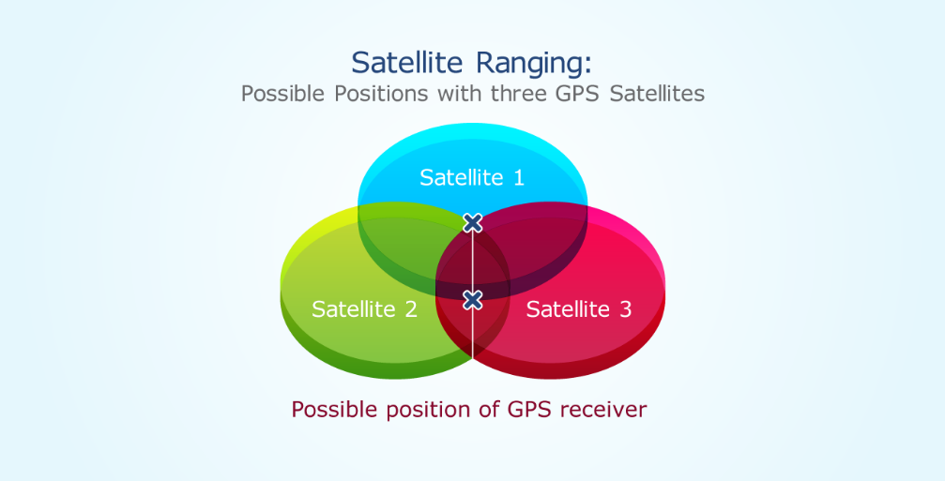

Wi-Fi Geolocation follows a different idea with the use of available access points around the world. A device will connect to an access point then send a unique ID to a remote application. The application will then use the unique ID and find it out from a list of access points around the world to determine approximate location. [14]

Figure 3 – Wi-Fi Geolocation Representation [14]

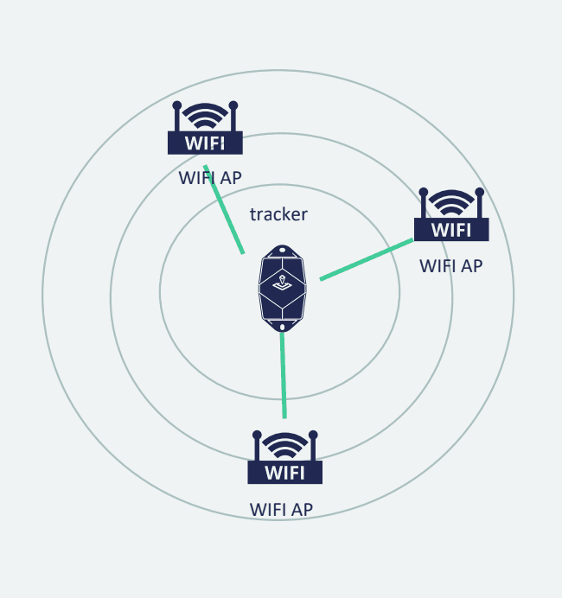

SPAT should be able to transmit the data logged by sensors and its location to the end user anywhere on the continental US. The TIVE Trackers utilize LTE-M and 2G networks for the transmission of data to the client.

LTE refers to Long Term Evolution and is a term used in conjunction with 4G nowadays. The difference between 4G and 4G LTE is LTE is a technology developed on top of established 4G networks to provide faster data transfers and lower latency. First introduced in 2008, the technology was developed as a new cellular network access with exceptional efficiency, high data rates, and flexibility in frequency and bandwidth. [11]

2G is the digital second generation of mobile networks to replace the first generation (1G) of analog cellular networks. First introduced in 1991 to the commercial market and has set a precedent for digital cellular networks for future iterations of cellular networks. It is still operable today to be used by electronic devices. [16]

*Viable Development Boards*

The SPAT is intended to be a small form factor tracker with a microcontroller at its core. There are a few viable development kits or microcontrollers for prototyping SPAT. Nordic Semiconductor, Norwegian based company that specializes in wireless communication technology since 1983. [17] The company offers development kits for sale like the nRF9160 and the nRF9151 that have GPS/Cellular communication and GPIO connectivity. The nRF9’s platform is programmable with C language using Nordic’s nRF Connect SDK. [20]

Microchip Technology Inc has the AVR-IoT Cellular Mini developed on AVR Microcontrollers platform. Microchip Technology Inc is heavily involved with smart, connected and secure embedded control. The company was founded in 1987 when it branched off its parent company, General Instruments, and became independent in 1989. [18] The AVR-IoT cellular is a low power microcontroller with GPIO pins to allow connectivity to external devices like temperature sensors. [19]

*Sensor Technology*

To properly measure the temperature of the medicine, temperature sensing can be accomplished using a variety of different methods. Resistance Temperature Detectors (RTDs) are a type of resistor that varies its resistance with temperature. Tying this to an instrumentation amplifier and ADC is a simple, low-cost way of reading the temperature of the surrounding electronics. Thermistors operate similarly to RTDs but use ceramic materials that create a non-linearity resistive response to a change in temperature. Meanwhile, RTDs have a linear response, making them more accurate. Infrared sensors can measure the temperature of an object from a distance, which means the local heat of the electronics has less of an effect. [1]

Pharmaceuticals are also quite sensitive to humidity. Measuring humidity can be done with a few different types of sensors. Optical humidity sensors use the refraction of the light between two fiber-optic cables created by the humidity to measure the total humidity of the environment. Capacitive humidity sensors are capacitors which change their capacitance with humidity by absorbing water into their dielectric. Resistive humidity sensors function similarly, with a ceramic or polymer resistor that absorbs water in the air which brings about a change in resistance. [2]

As instructed by the sponsor, a light detector will be used to protect light-sensitive pharmaceuticals. Light sensing is done with a few different types of electrical sensors that change their electrical characteristics based on the amount of ambient light in the surrounding area. Photo resistors operate similarly to their thermistor counterparts, changing in resistance based on the total amount of lumens seen by the resistor. Photo transistors are BJT which have an adjustable Beta value governed by light. Photo diodes generate electrical current based on the present light. This current can be converted to a readable voltage by using a trans-impedance amplifier matched to an ADC. [3]

V. PROBLEM STATEMENT

The biopharmaceutical industry loses about $35 billion each year due to temperature-related issues during transportation, which accounts for 15% of all biopharmaceutical waste. These losses affect not only the companies but also the consumers who rely on life-saving medicines and medical devices. When these products are exposed to improper temperatures, they can become unusable and unsafe for human use. As a result, industry is seeking solutions to ensure the safe and secure transport of these sensitive assets, so people can receive the care they need. By addressing this problem, companies can reduce waste and minimize the $35 billion in losses

VI. PROJECT OBJECTIVE

The objective of our project is to construct a pharmaceutical tracker that will monitor its environment (temperature, humidity, and light) within 1% of the actual value, and trace where it is in the continental United States.

VII. SUMMARY

The project discussed in this report is the Smart Pharmaceutical Asset Tracker (SPAT). The SPAT will be designed for the biopharmaceutical industry, which faces an annual loss of around $35 billion due to temperature-related damage during transportation. The project seeks to mitigate this loss by creating an electronic device capable of monitoring critical environmental factors such as temperature, humidity, and light exposure. The device will collect real-time data and communicate this information to the end-users to prevent product failures and reduce waste. This project is poised to have a significant impact on reducing waste, safeguarding pharmaceutical products, and ensuring that life-saving pharmaceuticals reach their destinations intact. The report covers the project's background, the challenges in pharmaceutical transportation, the objectives of the SPAT, and the end deliverables. The next steps include developing a minimal viable product. Some features include ensuring the end user can communicate with the SPAT. Another feature is ensuring the SPAT can communicate with the storage device of the assets. Lastly, ensuring effective sensor integration so the SPAT can acquire and relay reliable data to the end user. The SPAT's successful deployment could greatly improve the industry's approach to transportation logistics, improving both financial loss and patient safety.​

VIII. REFERENCES

[1] “Precision Temperature Sensors in CMOS Technology,” Google Books, 2024. <https://books.google.com/books?hl=en&lr=&id=gM8cyvhiofcC&oi=fnd&pg=PR11&dq=types+of+Temperature+sensors&ots=yHXOz4-oVb&sig=pff6lxwzZpFwNkR1bAjNB_b143M> (accessed Oct. 25, 2024).

[2] C.-Y. Lee and G.-B. Lee, “Humidity Sensors: A Review,” Sensor Letters, vol. 3, no. 1, pp. 1–15, Jan. 2005, doi: <https://doi.org/10.1166/sl.2005.001>.

[3] Papalias, Tamara A., and Mike Wong. "Making sense of light sensors." Electronic Engineering Times (2006): 10-14.

[4] iGPS, “Pharmaceutical Shipping Regulations Basic Guidelines for Pharma Transport” , iGPS, 2024, [Online] Available: <https://igps.net/pharmaceutical-shipping-regulations-basic-guidelines-for-pharma-transport/> [Accessed: October 20, 2024].

[5] “CFR - Code of Federal Regulations Title 21,” *www.accessdata.fda.gov*. <https://www.accessdata.fda.gov/scripts/cdrh/cfdocs/cfCFR/CFRSearch.cfm?fr=205.50> [Accessed: October 20, 2024].

[6] “Don’t Be Tempted to Use Expired Medicines,” *U.S. Food and Drug Administration*, 2019. <https://www.fda.gov/drugs/special-features/dont-be-tempted-use-expired-medicines> [Accessed: October 21, 2024]

[7] M. Mikulic, “Drug prescription volume U.S.,” *Statista*, Sep. 15, 2023. <https://www.statista.com/statistics/238702/us-total-medical-prescriptions-issued/> [Accessed: October 21, 2024]

[8] “Compare Trackers,” *Tive.com*, 2021. <https://www.tive.com/compare-trackers> [Accessed: October 21, 2024]

[9] “About us - Tive,” *Tive.com*, 2023. <https://www.tive.com/company> [Accessed: October 21, 2024]

[10] “What is Real-time Tracking ​in Logistics? Definition & Overview,” *Locus*. <https://locus.sh/resources/glossary/real-time-tracking/> [Accessed: October 21, 2024]

[11] H. Remmert, “What is LTE: How It Works and Why It Matters,” *www.digi.com*, Nov. 19, 2021. <https://www.digi.com/blog/post/what-is-lte> [Accessed: October 21, 2024]

[12] J. Kyes, “What Is GPS? Quick Overview and How It Works | Geotab,” *Geotab Blog*, Oct. 27, 2017. <https://www.geotab.com/blog/what-is-gps/> [Accessed: October 21, 2024]

[13] “Cell Phone Tower Triangulation - Cell Tower Triangulation,” *All in Investigations*. <https://www.iiiweb.net/forensic-services/cell-phone-tower-triangulation/> [Accessed: October 21, 2024]

[14] “Wi-Fi Technology and Accurate Geolocation 2023,” Jan. 09, 2023. <https://www.sensolus.com/wi-fi-technology-and-geolocation/> [Accessed: October 21, 2024]

[15] “Comparison of 2G 3G 4G 5G | 2G vs 3G vs 4G vs 5G | Rantcell,” *www.rantcell.com*. <https://www.rantcell.com/comparison-of-2g-3g-4g-5g.html> [Accessed: October 21, 2024]

[16] S. Dahmen-Lhuissier, “ETSI - 2g - Global System for Mobile Communication (GSM),” *ETSI*. <https://www.etsi.org/technologies/mobile/2g> [Accessed: October 21, 2024]

‌[17] “About Nordic Semiconductor” *www.nordicsemi.com*. <https://www.nordicsemi.com/About-us> [Accessed: October 21, 2024]

[18] W. I. M. LLC, “An Introduction to Microchip Technology (MCHP),” *Weitz Investment Management, Inc.* <https://weitzinvestments.com/perspectives/investment-insights/a-228/introduction-to-microchip-technologies.fs> [Accessed: October 21, 2024]

[19] “EV70N78A,” *Microchip.com*, 2024. <https://www.microchip.com/en-us/development-tool/ev70n78a> [Accessed: October 21, 2024]

[20] “Cellular IoT - Nordic Semiconductor,” *Nordicsemi.com*, 2024. <https://www.nordicsemi.com/Products/Wireless/Low-power-cellular-IoT> [Accessed: October 21, 2024]

[21] “Jay Weitzen: Electrical & Computer Engineering: Francis College of Engineering,” Electrical & Computer Engineering | Francis College of Engineering | UMass Lowell, https://www.uml.edu/Engineering/Electrical-Computer/faculty/weitzen-jay.aspx [Accessed Oct. 25, 2024].

[22] “Space systems,” Draper, https://www.draper.com/market-areas/space-systems [Accessed Oct. 25, 2024].

[23] R. Lauer, “Use Cell Tower and Wi-Fi Triangulation to Achieve Pin-Point Locations, without GPS,” *Blues*, Aug. 04, 2022. <https://blues.com/blog/use-cell-tower-and-wi-fi-triangulation-to-achieve-pin-point-locations-without-gps/>

‌

‌

‌

‌

‌

‌

‌

‌

‌

‌

‌

‌

‌

‌

IX. APPENDICES